**Manager registration**

1. Manager navigate to the system and select to register
2. Applicant fills application form, preview and submit.
3. If the application is complete, the system generated login credentials and notify manager via email.
4. If the application is incomplete, notify the manager to make amendment.

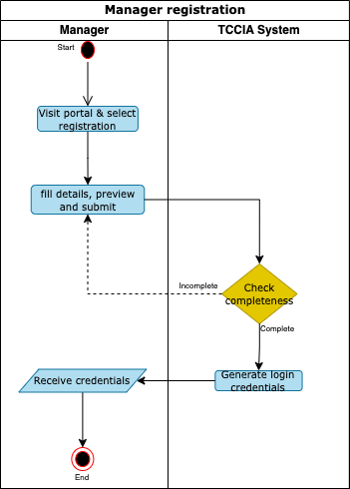

**Firm registration**

1. Manager login to the system, navigate to firm registration, fill form details including TIN number, preview and submit.
2. The system sends TIN number to TRA for verification.
3. If valid, the system displays manufacturer’s details for approval or rejection by the manager.
4. If approved, system add manufacture’s details to manager’s profile.
5. If rejected, process end.

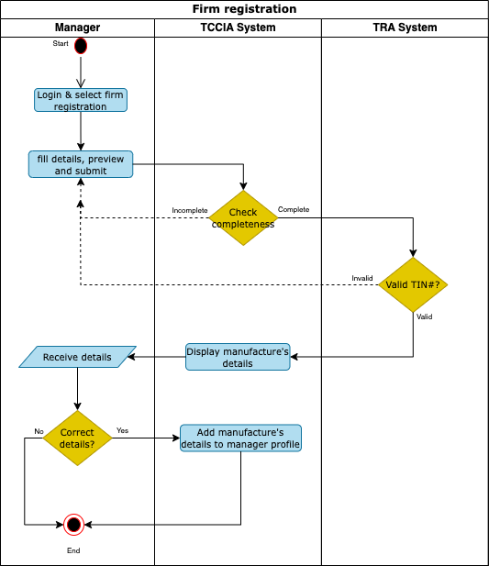

**Officer registration**

1. Manager login to the system, navigate to officer registration, fill form details including specifying company/ies (where the officer will have roles), preview and submit.
2. If the application is complete, the system generates login credentials and notify officer via email.
3. If the application is incomplete, notify the manager to make amendment.
4. Officer receives notification, click the link, set password and submit.
5. System saves new credentials and send notification to the officer.

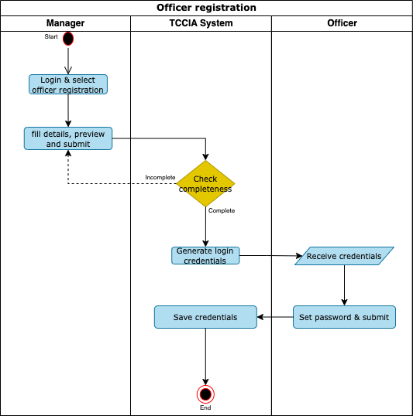

**CFA Selection**

1. Manager login to the system, navigate to agent selection, select Agent, specifying company/ies (where the Agent will act on behalf), preview and approve.
2. If approved, the system sends selection notification to CFA.
3. If rejected, process end.

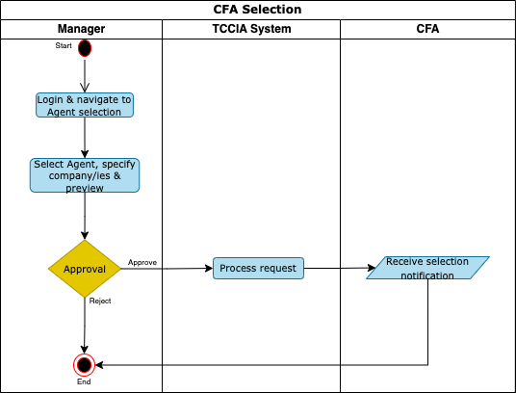

**Application for factory verification**

1. Applicant login into the system navigate to factory verification module and fill product details, add suggested date for inspection, upload necessary attachments, preview and submit.
2. If the application is complete, the system send notification to Industrial Manager.
3. If the application is incomplete, notify the Applicant to make amendment.
4. Industrial Manager review application, assign to REO/Qualified Inspector/s(Inspector), schedule for factory verification and submit to the Executive director for approval.
5. Executive director reviews the assigned Inspectors and approve or reject.
6. If approved, system send notification to Applicant and Inspector contains list of assigned inspectors and scheduled factory verification.
7. The Inspector conduct inspection, fills the inspection form, prepare inspection report, preview and submit to Applicant for acceptance.
8. The Applicant review the inspection report and accept/dispute.
9. If disputed, system notify Applicant to apply for another factory verification.
10. If accepted, System completes the inspection report by adding names & signature of inspector and applicant to the report, send notification to Applicant, Industrial Manager, Inspector and REO and forward the completed inspection report to TRA for further action.

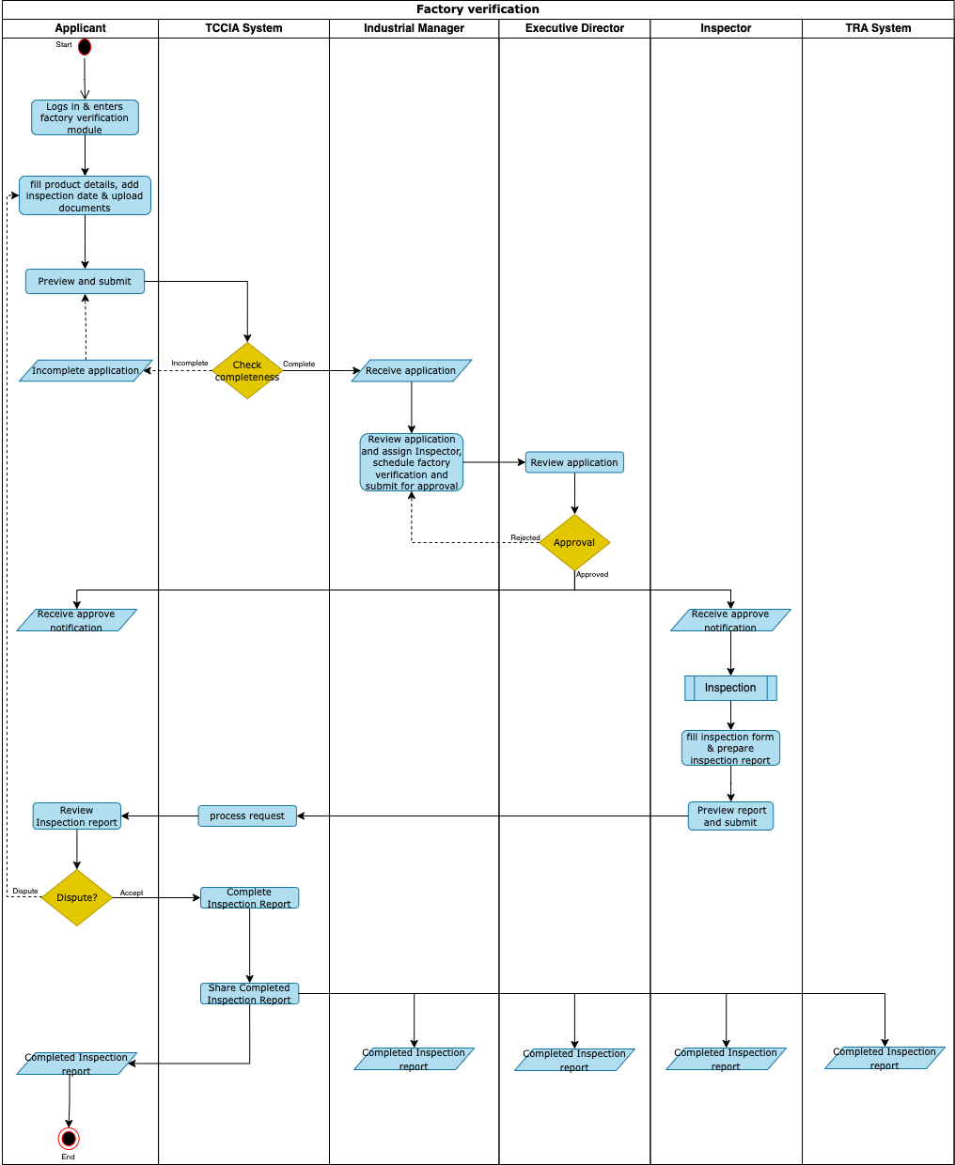

**Certificate of Original**

1. Applicant (Manager/CFA/Officer) login into the system, navigate to apply for the certificate of original, fill product details, enter assessment number/tansad number, upload necessary attachments and submit.
2. The system sends TRA assessment number to TRA system for verification and display export’s details for approval or rejection by Applicant.
3. If approved, the Applicant complete application form, preview and submit for evaluation.
4. The Evaluator review the application, recommend for approval or rejection and submit to the approver.
5. The Approver review the application and make determination.
6. If approved, the system generates control number and bill notification sent to Applicant.
7. The Applicant receive notification and make payment.
8. The system generate certificate of original, share generated Certificate of original to TRA and send notification to Applicant.
9. If rejected, the system sends rejection notification with remarks to the Applicant.

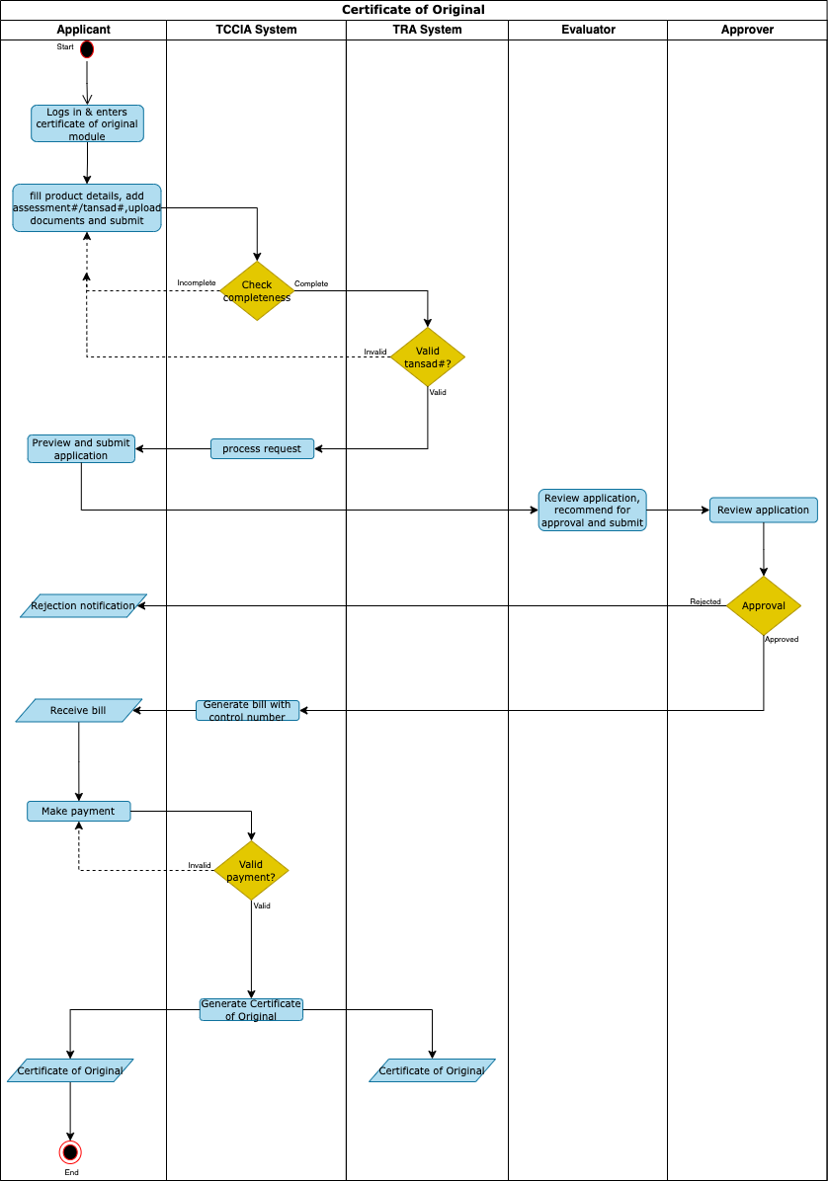

**CFA registration**

1. The CFA navigate to the system and select CFA registration.
2. The CFA enter TAFFA ID number and other details.
3. The system sends TAFFA ID to TRA for verification and display CFA’s details for approval or rejection by Applicant.
4. If approved, the Applicant complete application form, preview and submit.
5. The system generated login credentials and notify Applicant via email.
6. If rejected, process end.

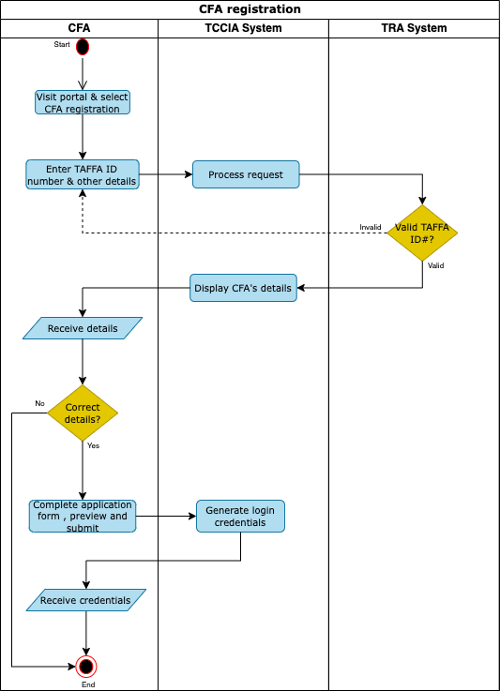

**CFA Officer registration**

1. The CFA Manager navigate to the system and select CFA officer registration.
2. The CFA Manager specifying company/ies, enter CFA’s officer TAFFA ID number and other details.
3. The system sends TAFFA ID to TRA for verification and display CFA’s officer details for approval or rejection by Applicant.
4. If approved, the CFA Manager complete application form, preview and submit.
5. The system generated login credentials and notify CFA officer via email.
6. CFA Officer receive notification, click the link, set password and submit.
7. System saves new credentials and send notification to the CFA officer.

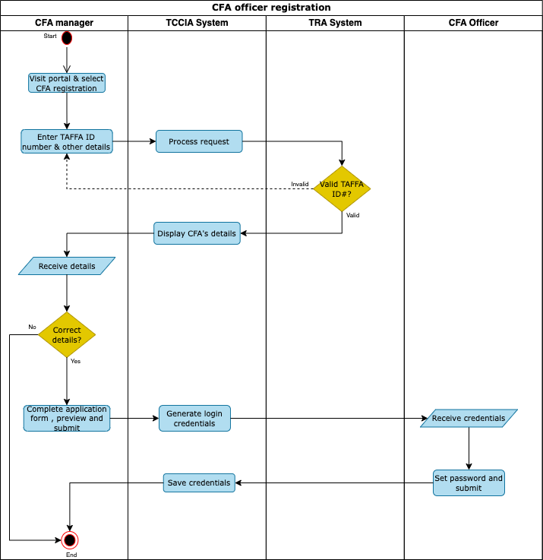

**Membership Application**

1. The Applicant/TCCIA Agent/TCCIA Officer navigate to membership application form, fill details, preview and submit.
2. System send notification to respective region based on membership category selected.
3. Membership officer review the application. If correct category is selected, the membership officer generate invoice containing control number and notification sent to Applicant. Else, the membership officer engages with the Applicant and make necessary correction followed by generating control number.
4. The applicant make payment.
5. The system generates membership certificate, login credentials and send notification to Applicant.

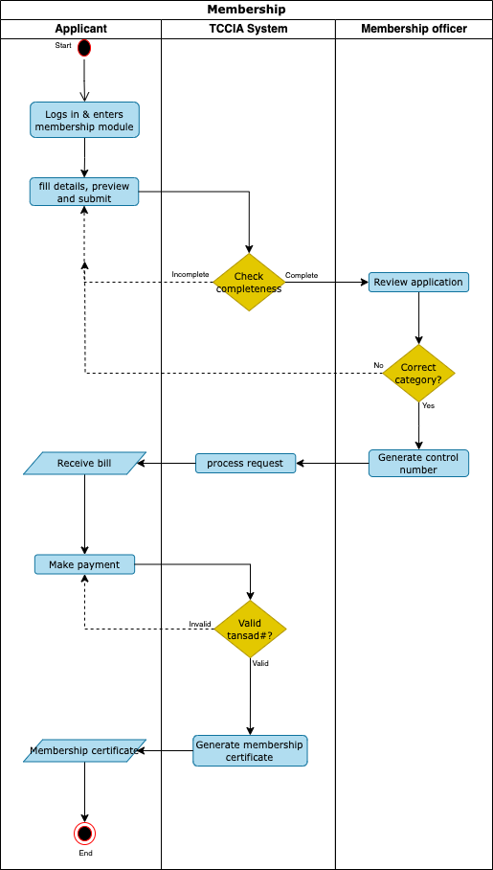

**Non-Tariff Barrier (NTB)**

1. Exporter/Trader access the appropriate communication channel (SMS, Mobile App or WhatsApp), fill details and submit.
2. The system receives NTB issue, send notification to the corresponding REO of the NTB reporter and HQ NTB Officer.
3. If report NTB need attention of REO, the REO select the relevant GDs to receive the reported NTB.
4. The system send notification to the contact person(s) of the selected GDs to attend the reported NTB.
5. The REO communicate with GD and provide feedback of the reported NTB.
6. If reported NTB need attention of HQ, the HQ NTB Officer select a region and assign the reported NTB.
7. The system enables HQ NTB Officer to forward the reported NTB to the selected GDs
8. The HQ NTB officer communicate with GD and provide feedback of the reported NTB.

**Membership (renew, change category(upgrade))**

**Complaints handling**

**Handing over duties**

**Bill & Payments**